<!DOCTYPE html>

<html lang="en">

<head>

<meta charset="UTF-8">

<meta name="viewport" content="width=device-width, initial-scale=1.0">

<link rel="stylesheet" href="styles.css">

<title>Placement Registration</title>

<style>

.error { color: red; }

</style>

</head>

<body>

<h1>Placement Registration Form</h1>

<form id="registrationForm" onsubmit="return validateForm()">

<label for="name">Name:</label>

<input type="text" id="name" required><br>

<label for="address">Address:</label>

<input type="text" id="address" required><br>

<label for="email">Email ID:</label>

<input type="email" id="email" required><br>

<label for="contact">Contact Number:</label>

<input type="tel" id="contact" required><br>

<label for="dob">Date of Birth:</label>

<input type="date" id="dob" required><br>

<label for="percentage">Percentage:</label>

<input type="number" id="percentage" required><br>

<label>Branch:</label>

<input type="radio" name="branch" value="AIDS">AIDS

<input type="radio" name="branch" value="CSE">CSE

<input type="radio" name="branch" value="IOT">IOT

<input type="radio" name="branch" value="EXTC">EXTC

<input type="radio" name="branch" value="Mechanical">Mechanical<br>

<label>Technology Preferred:</label>

<input type="checkbox" name="tech" value="Ruby">Ruby

<input type="checkbox" name="tech" value="C#">C#

<input type="checkbox" name="tech" value="Go">Go

<input type="checkbox" name="tech" value="Perl">Perl

<input type="checkbox" name="tech" value="Php">PHP<br>

<input type="submit" value="Submit">

</form>

<p class="error" id="errorText"></p>

<script>

function validateForm() {

var name = document.getElementById("name").value;

var address = document.getElementById("address").value;

var email = document.getElementById("email").value;

var contact = document.getElementById("contact").value;

var dob = new Date(document.getElementById("dob").value);

var percentage = parseFloat(document.getElementById("percentage").value);

var branchSelected = document.querySelector('input[name="branch"]:checked');

var techSelected = document.querySelectorAll('input[name="tech"]:checked').length;

var errorText = document.getElementById("errorText");

errorText.innerHTML = "";

// Regular expression to validate a phone number (10 digits)

var phoneRegex = /^\d{10}$/;

if (name === "" || address === "" || email === "" || !phoneRegex.test(contact) || dob === "" || isNaN(percentage) || !branchSelected || techSelected === 0) {

errorText.innerHTML = "Please Fill in All Fields or Provide a Valid Contact Number.";

return false; }

if (!email.includes("@") || !email.includes(".")) {

alert("Please Enter a Valid E-Mail Address.");

return false; }

if (percentage < 60) {

alert("Percentage Must be Minimum First Class (>= 90%).");

return false; }

return true; }

</script>

</body> </html>

**#styles.css**

/* Styling for the form */

body {

font-family: Arial, sans-serif;

background-color: #f5f5f5;

margin: 0;

padding: 0;

}

h1 {

text-align: center;

margin-top: 20px;

color: #333;

}

form {

max-width: 600px;

margin: 0 auto;

padding: 20px;

background-color: #fff;

border-radius: 5px;

box-shadow: 0 0 5px rgba(0, 0, 0, 0.2);

}

label {

font-weight: bold;

display: block;

margin-top: 10px;

}

input[type="text"],

input[type="email"],

input[type="tel"],

input[type="date"],

input[type="number"] {

width: 100%;

padding: 8px;

margin-bottom: 10px;

border: 1px solid #ccc;

border-radius: 3px;

box-sizing: border-box;

}

input[type="radio"],

input[type="checkbox"] {

margin-right: 5px;

}

input[type="submit"] {

display: block;

width: 100%;

padding: 10px;

background-color: #333;

color: #fff;

border: none;

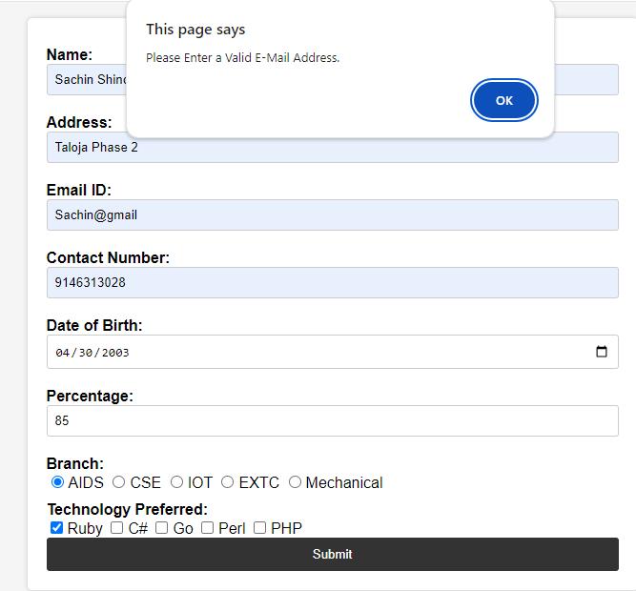 border-radius: 3px;

cursor: pointer;

}

/* Error message styling */

.error {

color: red;

margin-top: 10px;

}

/* Responsiveness */

@media (max-width: 480px) {

form {

padding: 15px;

}

}

